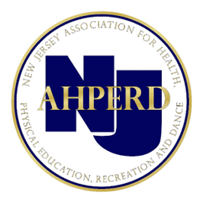
2023-2024 NJAHPERD ADVOCACY PRIORITIES

Support New Health and Physical Education Student Learning Standards (NJSLS)
NJAHPERD continues to support the new health and physical education student learning standards adopted by the State Board of Education in 2020, to be implemented in the 2022-23 school year.
Ensure Recently Enacted HPE Mandates are Followed
In the 2019-20 school year both mandatory recess for elementary schools (K-5) and health and physical education teacher certification (K-6) laws went into effect in public schools in New Jersey. The recess law requires a daily minimum 20 minutes recess period, which will ensure that young students are receiving the necessary daily break needed to enhance educational, physical, and social development.
The health and physical education certification law applies to new teachers in grades K-6 and will ensure that certified health and physical education teachers receive appropriate, comprehensive training and necessary pedagogical preparation, and that NJ students are receiving effective instruction by a specialist in required health and physical education courses.
In 2014, the law requiring public school districts serving students in grades 9-12 to provide instruction in cardiopulmonary resuscitation (CPR) and automated external defibrillation (AED) use was enacted. This instruction must be provided prior to graduation as part of the implementation of the current New Jersey Core Curriculum Content Standards (NJCCCS) in Comprehensive Health and Physical Education.
NJAHPERD will work to ensure these mandates are followed in New Jersey Public Schools.
Show Importance of 150 Minute Health, Safety and Physical Education Mandate
NJ law requires every public-school student in grades 1-12 to receive 150 minutes of health, safety, and physical education per week. NJAHPERD will be vigilant to ensure that this requirement is maintained in current law. In addition, NJAHPERD will work to see that this law is followed in schools throughout New Jersey, by continuing to provide information to school administrators discussing the importance of this mandate and how it can be followed in their schools.
Support Legislation Strengthening State Drivers Education Requirements Many NJAHPERD members teach drivers education courses in their local schools. NJAHPERD will continue to work with the NJ Department of Education and Motor Vehicle Commission (“MVC”) to ensure that any changes to the law benefit NJ students, including supporting legislation that increases the practice driving requirement for NJ permit holders (under 21) to 50 hours, including 10 hours at night.

