NJ Student Learning Standards
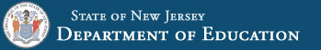
SHAPE NJ encourages our community to review the new standards and take advantage of our workshops and conferences which will highlight the new content!
NJ Student Learning Standards - Revised 2020
For lessons, resources and assessments aligned to the new standards: Check out some of these outstanding FREE resources:
www.3rs.org
www.kidshealth.org All the links are active!
www.cbhpe.org
www.openphysed.org
www.dynamicpeasap.com
www.joinonelove.org
www.myplate.gov

